Mr. Henry,

Week 9 has been a tough one. I now have a majority of my site and its features built, but I am really struggling with the testing features and abilities.

I am quickly realizing that it is one thing to research, follow along with tutorials and build small mock applications and its another to try and implement it into my project. Unit tests are kind of kicking my butt and because I don't have a lot of my logic separate from my actual code-behind pages I'm running into road blocks when it comes to writing unit tests.

I've created the Unit Test project in my solution and am able to reference my methods, but I'm struggling getting the results I want and how to input the data I want to test different scenarios.

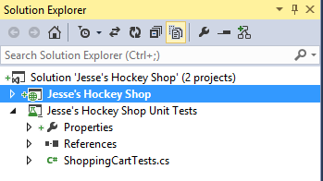

As far as the other Unit and Load testing I'm finding that I need to run the test while on an actual production web site so I was going to ask if I could get a web area similar to my CSCI 181 Intro to Web Design. I'd really like to be able to upload it online so that I can begin with the UI Tests as well as have a site to reference during my presentation.

I'm going to try and arrange for some time to meet with some of my colleagues at Orbital Shift to help me get a better understanding of Unit Tests and am working directly with Kevin to try and see how Orbital Shift uses Unit Tests but I am kind of stuck right now.

If you have any other references or suggestions on where to look for help that would be much appreciated.

Thanks again,

Jesse Fulcher